# **World Design**

Abyssal Legacy is a campaign expansion pack that introduces EkIII, a new star system that’s discovered to be infested with Zergs. The player will play as Zerg leaders from this system in the story and fight against the Protoss and Terran.  
 

Tartarus VII is a planet in the EkIII system. It’s mostly rocks and minerals. Far before the first great war, this planet has been taken over by the Zerg faction and has been a secret Zerg colony since. The surface of this planet is mostly covered in cliffs and acidic puddles, making it highly inhospitable. The Zergs have taken a liking to living underground caves.   
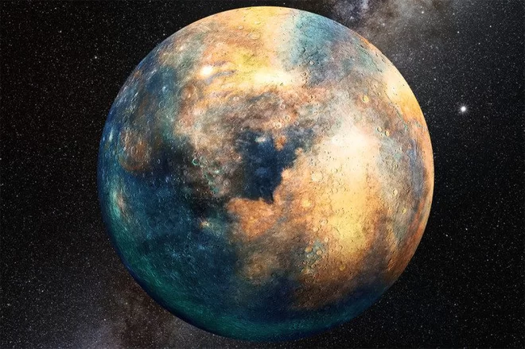  
During the new campaign, the Nerazim (Protoss faction) launched an attack and destroyed several planets in the process with their eclipse orbital cannon. Tartarus VII being one of the planet targeted in the first wave of attack, was left in ruins. The Zergs of EkIII responded with a counter attack, which later lead to them joining the war against both Protoss and Terran.

Star System Theme:

Zerg infestation

Planet Theme:

Underground Zerg caves

Mountain range

Acid puddles